Practical & Theoretical Foundations of Ethical Hacking & VAPT Operations Report

Author: Mohammed Hasan Shaikh, Report Updated On: 04/03/2026

Contents
Practical & Theoretical Foundations of Ethical Hacking & VAPT Operations Report 1
1. Introduction 3
2. Vulnerability Scanning 3
2.1. Email To Developers with PoC 7
3. Perform OSINT: Maltego & Shodan 7
3.1. Using Maltego on Metasploitable2 8
3.2. Using Shodan On Metasploitable2 10
3.3. Recon Summary 11
4. Exploitation Lab Using Metasploit Framework 11
4.1. Exploit Metasploitable2 Machine 12
4.2. Exploit Windows 7 Machine 14
5. Exploit DVWA for SQL Injection 17
5.1. Remediation Method 20
5.2. Reporting 22
5.3. Non-Technical Summary 23
6. Using Wappalyzer 23
7. Lessons Learnt & Conclusion 24
8. References 24

Introduction
This report will present a comprehensive study and practical implementation of Vulnerability Assessment and Penetration Testing (VAPT) methodologies, integrating theoretical foundations with hands-on laboratory exercises. The theoretical component will examine vulnerability scanning techniques, including network and application scanning using tools such as Nmap and OpenVAS, alongside authenticated versus unauthenticated assessments and risk prioritization through CVSS v4.0 scoring. The report will further explore structured penetration testing methodologies, including PTES and OWASP Web Security Testing Guide, covering reconnaissance, scanning, exploitation, post-exploitation, and reporting phases, while emphasizing ethical scope and authorization requirements.

I will conduct practical applications in controlled lab environment in Kali Linux using platforms such as Metasploit, sqlmap, Maltego, Shodan, and DVWA to simulate real-world attack scenarios. Activities include scanning Metasploitable2 targets, conducting OSINT reconnaissance, exploiting web vulnerabilities such as SQL injection, performing privilege escalation, validating findings against Exploit-DB proof-of-concepts, and documenting evidence with cryptographic hashing. Additionally, I will be taking screenshots and constructing suitable tables as evidence of my findings.

Vulnerability Scanning
In this segment of the report, I will run Nmap and OpenVAS scan on Metasplopitable2 machine and document its vulnerabilities.

Target Metasploitable2 Machine IP Address: 192.168.1.26
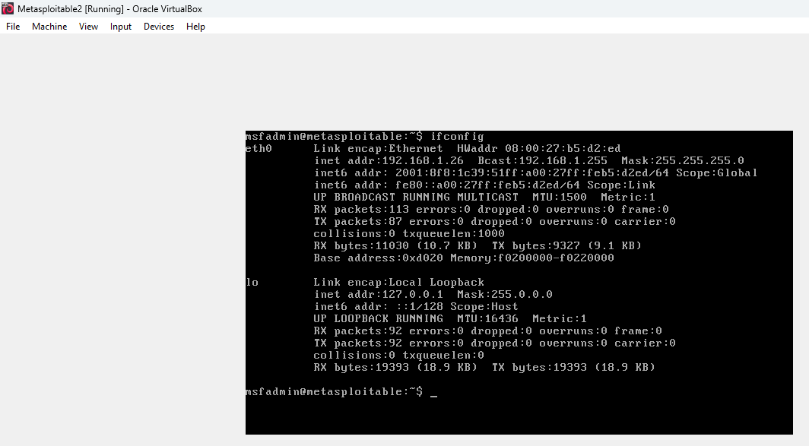

Figure 1: Metasploitable2 Machine IP Address

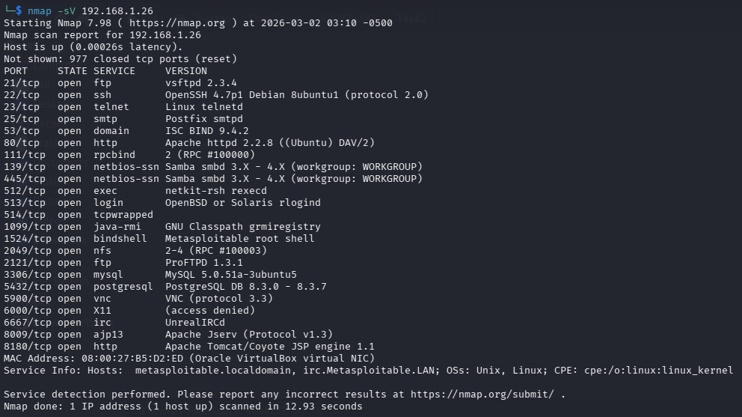

Figure 2: Metasploitable2 Machine Open Ports & Services through Nmap

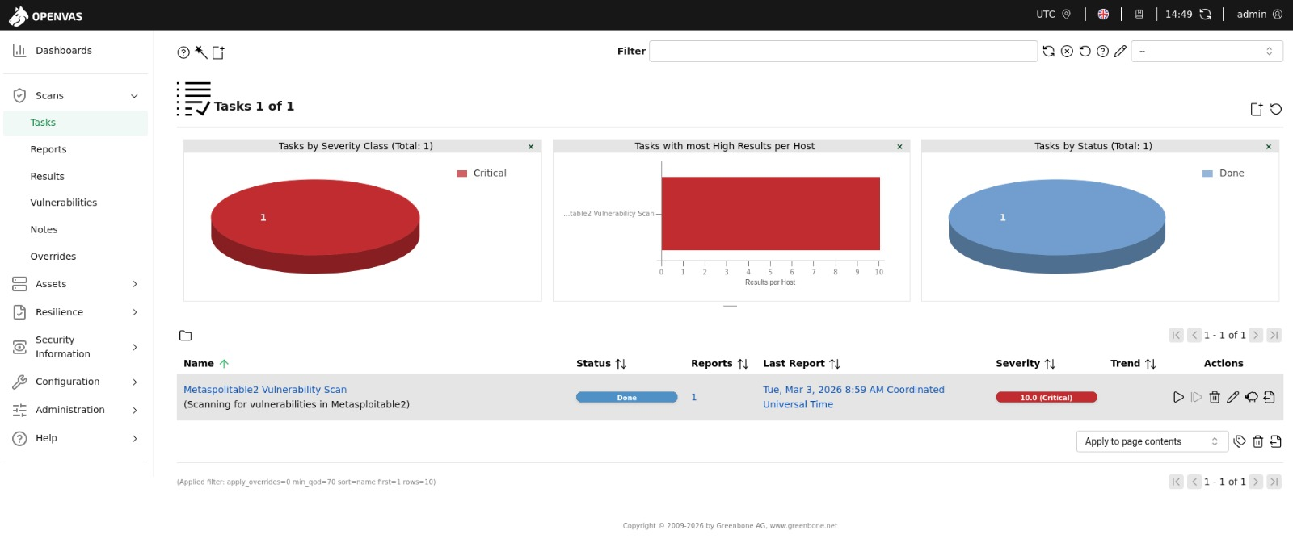

Figure 3: Metasploitable2 Machine (OpenVAS Scan - Tasks)

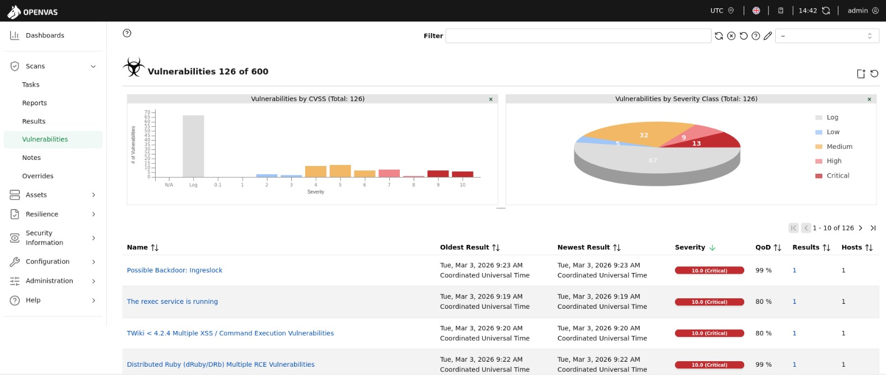

Figure 4: Metasploitable2 Machine (OpenVAS Scan - Vulnerabilities)

The below shows the vulnerability table.

Scan ID | Vulnerability | CVE ID | CVSS Score | Priority | Host
001 | Apache Tomcat AJP RCE Vulnerability | CVE-2020-1938 | 9.8 | critical | 192.168.1.26
002 | MySQL Default Credentials | CVE-2001-0645, CVE-2002-1809, CVE-2004-1532, CVE-2004-2357, CVE-2006-1451, CVE-2007-2554, CVE-2007-6081, CVE-2009-0919, CVE-2014-3419, CVE-2015-4669, CVE-2016-6531, CVE-2018-15719,  CVE-2024-22901 | 9.8 | critical | 192.168.1.26
003 | UnrealIRCd Backdoor | CVE-2010-2075 | 7.5 | high | 192.168.1.26
004 | rsh Unencrypted Cleartext Login | CVE-1999-0651 | 7.5 | high | 192.168.1.26
005 | FTP Brute Force Logins With Default Credentials Reporting | CVE-1999-0501, CVE-1999-0502, CVE-1999-0507, CVE-1999-0508, CVE-2001-1594, CVE-2013-7404, CVE-2014-9198, CVE-2015-7261, CVE-2016-8731, CVE-2017-8218, CVE-2018-9068, CVE-2018-17771,  CVE-2018-19063,  CVE-2018-19064,  CVE-2018-25147,  CVE-2020-36915 | 7.5 | high | 192.168.1.26
006 | Anonymous FTP Login Reporting | CVE-1999-0497 | 6.4 | medium | 192.168.1.26
007 | jQuery < 1.9.0 XSS Vulnerability | CVE-2012-6708 | 6.1 | medium | 192.168.1.26
008 | TCP Timestamps Information Disclosure | - | 2.6 | low | 192.168.1.26
009 | Weak MAC Algorithm(s) Supported (SSH) | - | 2.6 | low | 192.168.1.26

The below shows the mitigation method for each vulnerabilities found.

Apache Tomcat AJP RCE Vulnerability (PATCH)
Update Apache Tomcat to version 7.0.100, 8.5.51, 9.0.31 or later

MySQL Default Credentials Vulnerability (PATCH)
Change the password as soon as possible. Contact the vendor for other possible fixes / updates

UnrealIRCd Backdoor Vulnerability (PATCH)
Install latest version of unrealircd and check signatures of software you're installing.

rsh Unencrypted Cleartext Login Vulnerability (PATCH)
Disable the rsh service and use alternatives like SSH instead.

FTP Brute Force Logins With Default Credentials Reporting Vulnerability (PATCH)
Change the password as soon as possible.

Anonymous FTP Login Reporting Vulnerability (PATCH)
If you do not want to share files, you should disable anonymous logins.

jQuery < 1.9.0 XSS Vulnerability (PATCH)
Update to version 1.9.0 or later.

TCP Timestamps Information Disclosure Vulnerability (PATCH)
To disable TCP timestamps on linux add the line 'net.ipv4.tcp_timestamps = 0' to /etc/sysctl.conf.
Execute 'sysctl -p' to apply the settings at runtime.

To disable TCP timestamps on Windows execute 'netsh int tcp set global timestamps=disabled'

Starting with Windows Server 2008 and Vista, the timestamp cannot be completely disabled.

The default behavior of the TCP/IP stack on this Systems is to not use the Timestamp options when initiating TCP connections, but use them if the TCP peer that is initiating communication includes them in their synchronize (SYN) segment.

Weak MAC Algorithm(s) Supported (SSH) Vulnerability (PATCH)
Disable the reported weak MAC algorithm(s).

Email To Developers with PoC

Escalation: The below is an email to developers with PoC.

Subject: Critical Vulnerabilities Identified – Immediate Action Required
Dear Development Team,
The recent OpenVAS/GVM scan identified multiple critical vulnerabilities on host 192.168.1.26. Notably, Apache Tomcat AJP RCE (CVE-2020-1938, CVSS 9.8) allows remote code execution via exposed AJP port 8009. PoC: nmap -p8009 --script ajp-methods <host> confirms exposure; exploitation can retrieve sensitive files (e.g., WEB-INF/web.xml). Additionally, MySQL default credentials (multiple CVEs, CVSS 9.8) permit unauthorized DB access. PoC: mysql -h <host> -u root -p (blank/default password). High-risk services (FTP, rsh, UnrealIRCd) are also exposed. Immediate patching, credential hardening, and service restriction are required.
Best Regards,
Hasan

Perform OSINT: Maltego & Shodan
In this segment of the report, I will perform OSINT on Metasploitable2 machine through Maltego and Shodan and record the findings through tables and screenshots.

Using Maltego on Metasploitable2

Domain Information Table

Field | Details
Primary IP Address | 192.168.1.26
Netblock (Primary) | 192.168.0.0 – 192.168.255.255
CIDR | 192.168.0.0/16
Netblock (Subnet) | 192.168.1.0 – 192.168.1.255
Net Type | IANA Special Use (Private Address – RFC1918)
Organization | Internet Assigned Numbers Authority
Parent Organization | ICANN
Registry | American Registry for Internet Numbers
Address | 12025 Waterfront Drive, Los Angeles, CA, US
Abuse Email | abuse@iana.org
Abuse Phone | +1-310-301-5820
RFC Reference | RFC1918 (Private Address Space)

Subdomains / DNS Names Identified

Dynamic DNS (alta.inc) Table

DNS Name
192-168-1-26.g3nxwgup1yj.ddns.manage.alta.inc
192-168-1-26.ga1l29x2oxa.ddns.manage.alta.inc
192-168-1-26.l3e7jcf4l6v.ddns.manage.alta.inc
192-168-1-26.lhh0kk98x61.ddns.manage.alta.inc
192-168-1-26.n3o0mz6iacr.ddns.manage.alta.inc
192-168-1-26.snfqhnkpkeq.ddns.manage.alta.inc
192-168-1-26.x3cyrr58u4t.ddns.manage.alta.inc

Remote / Device-Based Hostnames (remotewd.com) Table

DNS Name
device-local-02123e1f-8fd5-4d18-920e-379546d4903a.remotewd.com
device-local-0330c745-fd75-411a-ad15-1c268bf2f603.remotewd.com
device-local-07411cc2-d7a0-4355-a574-ae68bbf0be4e.remotewd.com
device-local-087bc852-b284-406d-be89-eeb5fea23cbc.remotewd.com
device-local-19792e05-7590-46a6-a010-f4e22747dab3.remotewd.com
device-local-2e73d1bb-cd37-4b91-a4a8-4c427092dab9.remotewd.com
device-local-4a9199a7-bae0-4231-a71d-8468e31b62c2.remotewd.com
device-local-910df8cd-feda-4f9a-950e-fbfc311d9889.remotewd.com
device-local-9e2879b8-c9d8-4f63-99f6-cfde9f97d086.remotewd.com
device-local-aa0bd938-896b-4dcb-a9df-60a5b4b31e0e.remotewd.com
device-local-b3f6aa81-04e7-49dc-94a7-650a06bfdf3e.remotewd.com
device-local-de4e17a4-8be0-4e00-9df9-b09863fa349d.remotewd.com
device-local-e03e9d37-93b6-426b-9f7e-7d3529f78e01.remotewd.com
device-local-e948babc-040d-4e65-86ec-4e2d6fbc538f.remotewd.com

Other Associated Domains Table

DNS Name
ks-at-kapfenberg.arena.keemotion.com
poseidon.rprwyatt.com
vpce-0c0b9a068f1930be8-zluxyt1b-us-west-2a.s3.us-west-2.vpce.amazonaws.com

Exposed Services / Infrastructure Observed

Based on the Maltego report, no specific TCP/UDP ports or service banners were listed.
However, the following infrastructure exposure indicators were observed:

Category | Details
IP Version | IPv4
IP Type | Private (RFC1918)
Network Range | 192.168.0.0/16
DNS Exposure | Multiple dynamic DNS mappings
Cloud Reference | AWS VPC Endpoint (s3.us-west-2)
Remote Device Hostnames | Multiple device-local entries
WHOIS Registry | ARIN
Governance Body | Internet Assigned Numbers Authority

Using Shodan On Metasploitable2
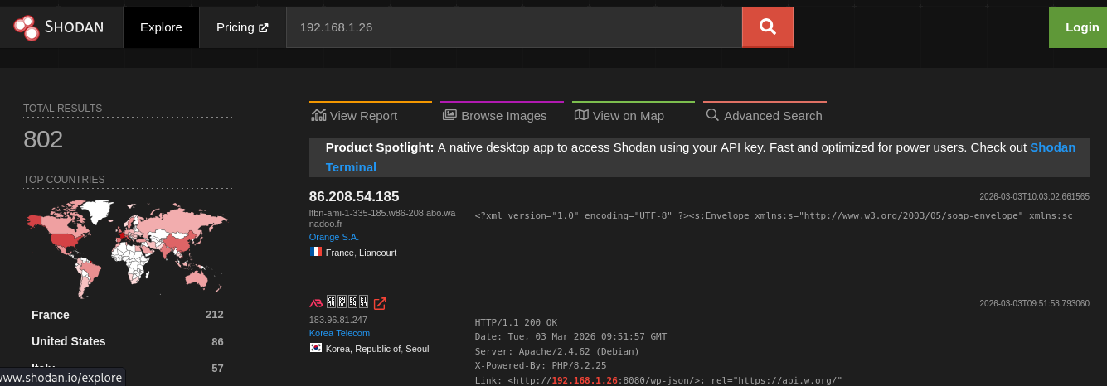

Figure 5: Shodan Search for Metapsloitable2 IP Address (192.168.1.26)

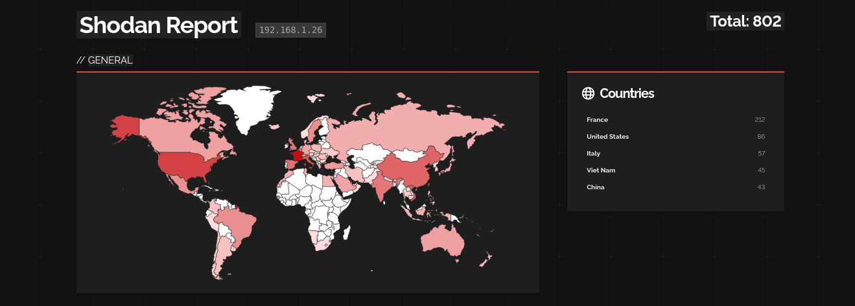

Figure 6: Shodan Report Page for Metapsloitable2 IP Address (192.168.1.26)

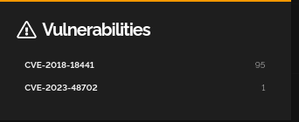

Figure 7: Metapsloitable2 Machine - Vulnerabilities Detected

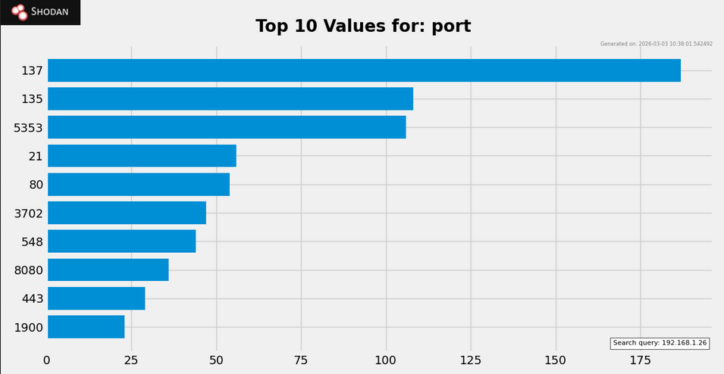

Figure 8: Metapsloitable2 Machine - Open Ports Detected

Recon Summary
Maltego report on 192.168.1.26 (private IP, RFC1918) reveals 24 DNS names, including 7 ddns.manage.alta.inc subdomains (e.g., 192-168-1-26.snfqhnkpkeq.ddns.manage.alta.inc), 15 device-local.remotewd.com, plus AWS VPC endpoint and others. No explicit exposed services or ports listed; focus on DNS enumeration and WHOIS data (IANA, abuse@iana.org). Total 51 entities linked.

Exploitation Lab Using Metasploit Framework
In this segment of the report, I will demonstrate on how I exploited Metasploitable2 machine and Windows 7 Machine successfully using Metasploit framework through screenshots as evidence.

Exploit Metasploitable2 Machine
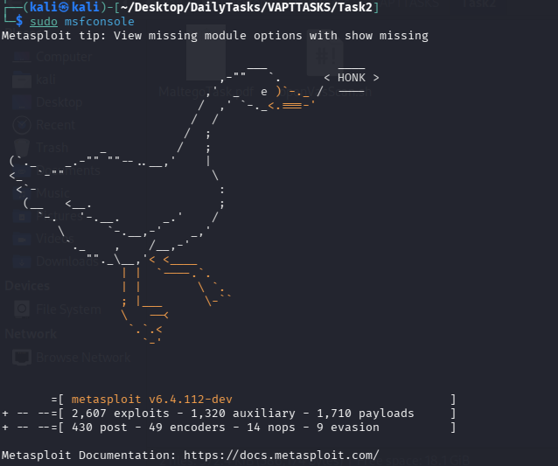

Figure 9: Step 1 - Open msfconsole

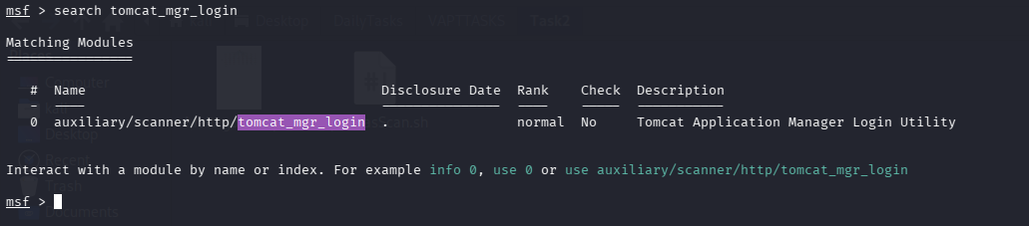

Figure 10: Step 2 - Search the exploit
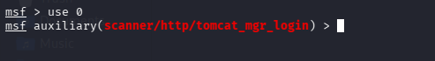

Figure 11: Step 3 - Use the exploit

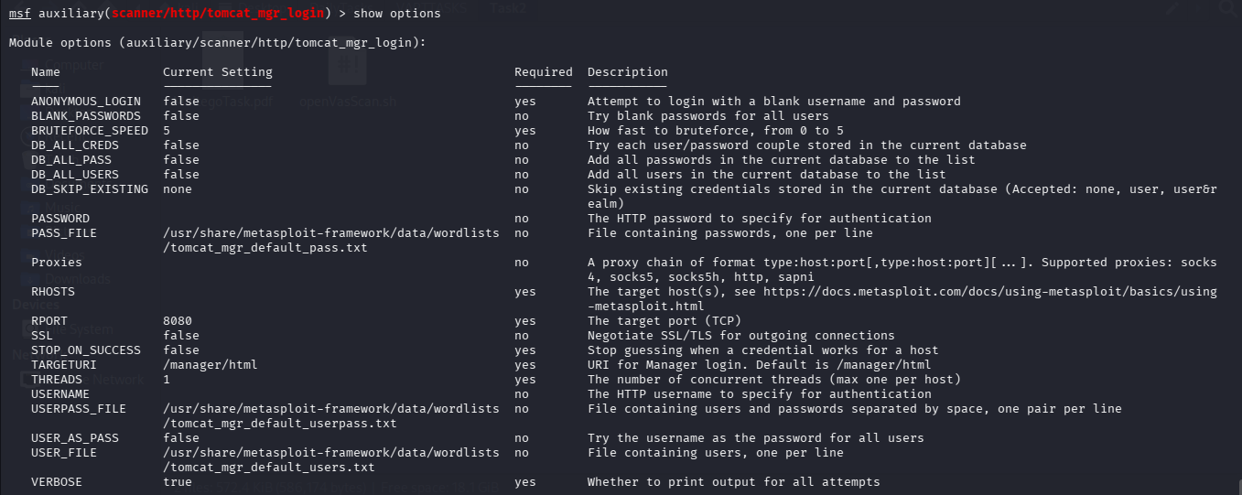

Figure 12: Step 4 – Check the options to fill in
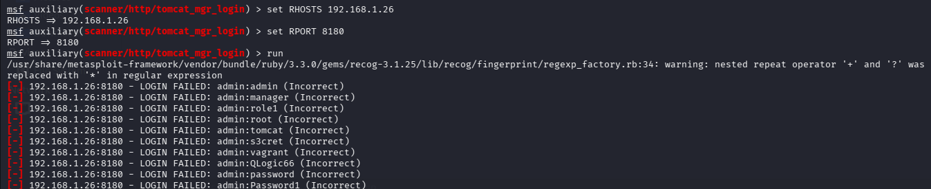

Figure 13: Step 5 – Fill the options accordingly and run the exploit

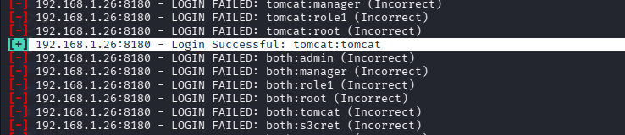

Figure 14: Step 6 – Credentials found, Login Successful

As shown above, Metapsloitable2 machine has been successfully exploited with credentials being found and login being successful.

Exploit-DB for PoC

This module can be used to execute a payload on Apache Tomcat servers that have an exposed "manager" application. The payload is uploaded as a WAR archive containing a jsp application using a PUT request. The manager application can also be abused using /manager/html/upload, but that method is not implemented in this module.

Exploit Windows 7 Machine
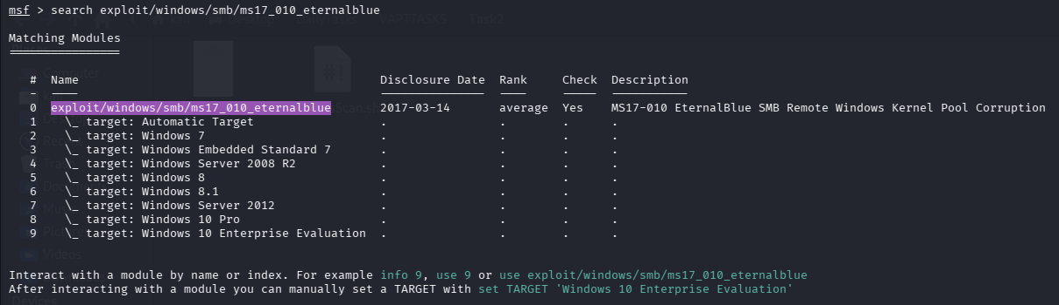

Figure 15: Step 1 – Search the exploit

Figure 16: Step 2 – Use the exploit

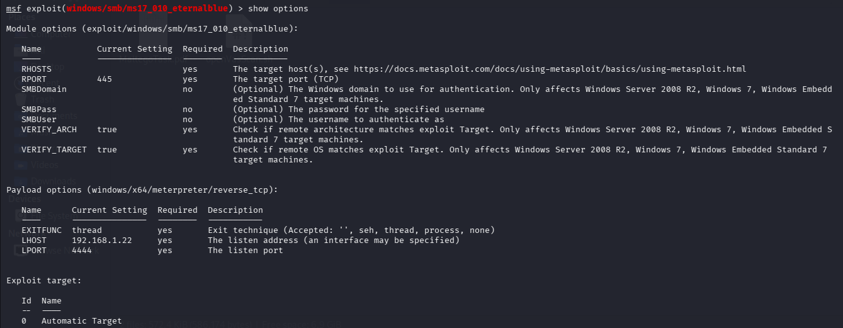

Figure 17: Step 3 – Check the options to fill in

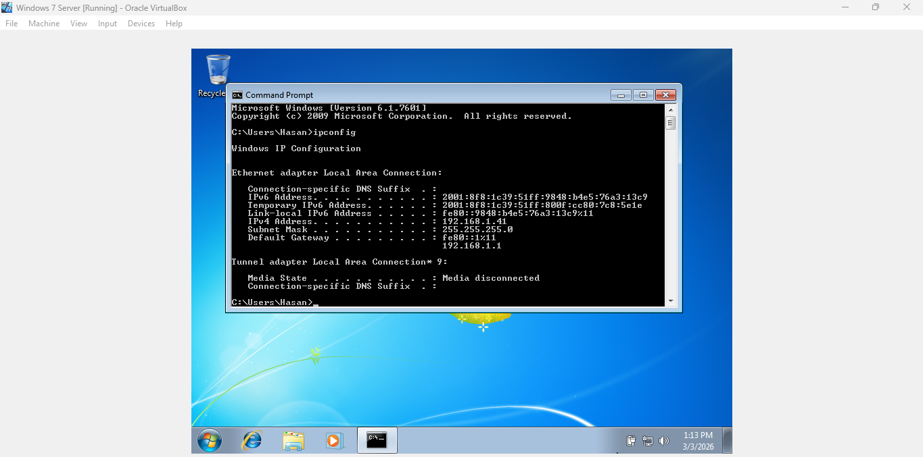

Figure 18: Step 4 – Record Windows 7 Machine IP Address

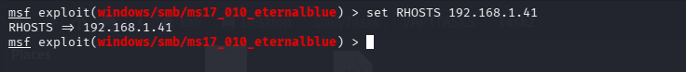

Figure 19: Step 5 – Set RHOSTS to Windows 7 Machine

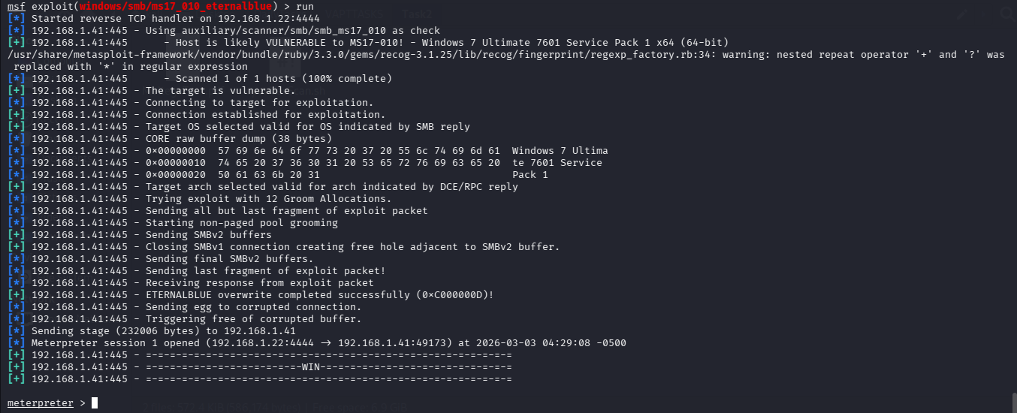

Figure 20: Step 6 – Enter ‘run’ and you get meterpreter session

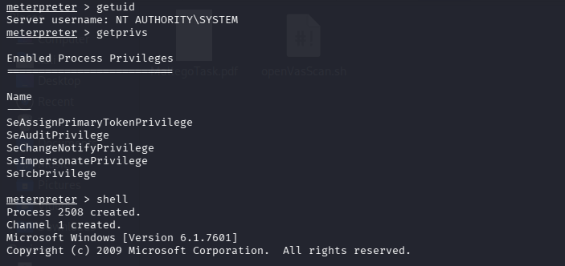

Figure 21: Step 7 – Info gathered_1

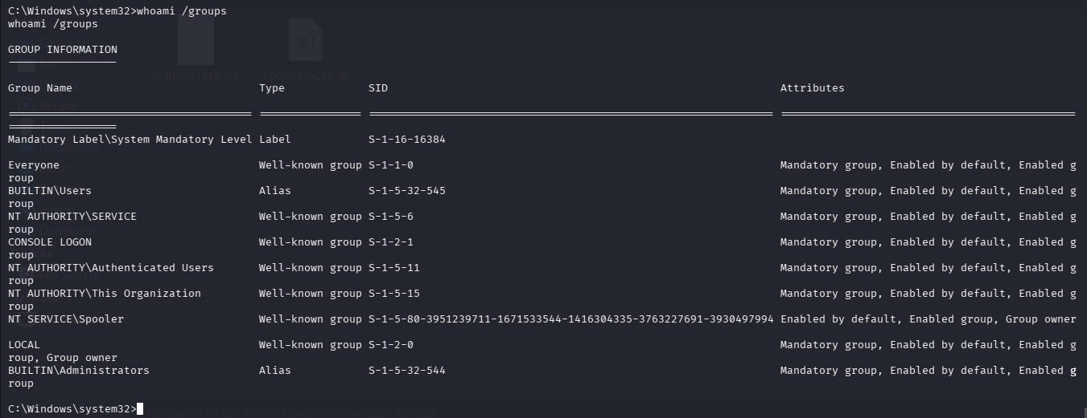

Figure 22: Step 8 – Info gathered_2

Figure 23: Step 9 – Hashes found

As shown above, Windows7 machine has been successfully exploited with hashes being found.

Exploit DVWA for SQL Injection
In this segment of the report, I will demonstrate on how I exploited DVWA website with sqlmap for SQL Injection with the help of screenshots taken as part of evidence.

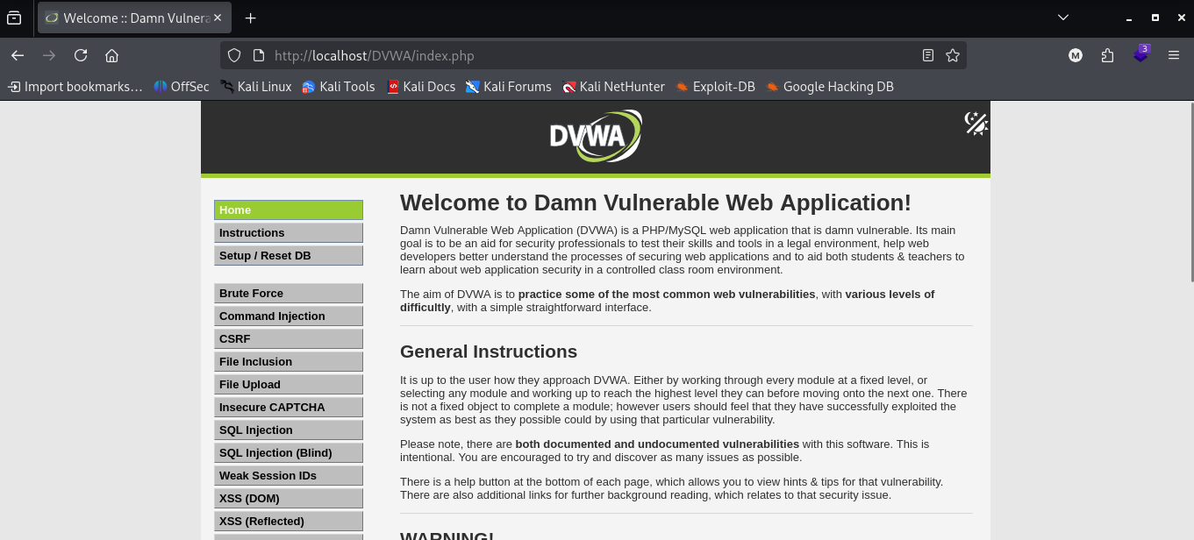

Figure 24: Step 1 – DVWA Dashboard

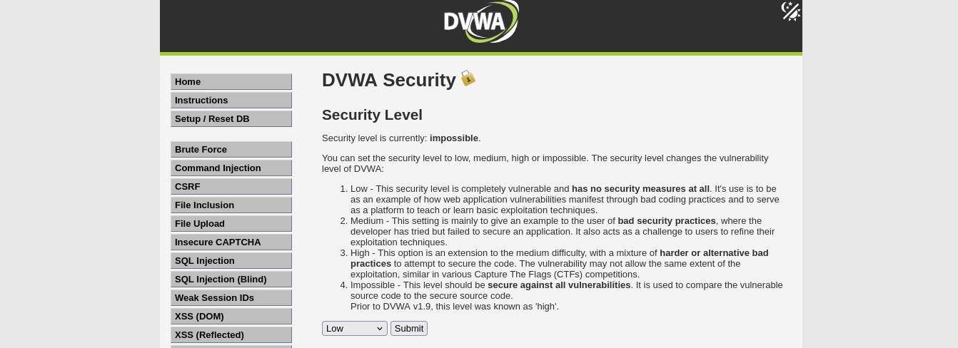

Figure 25: Step 2 – Set DVWA Security Level to Low and click submit

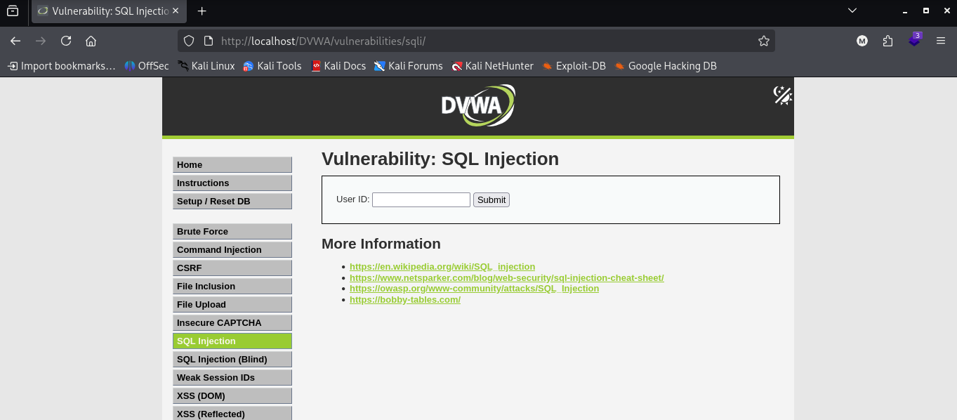

Figure 26: Step 3 – Go to DVWA SQL Injection Page

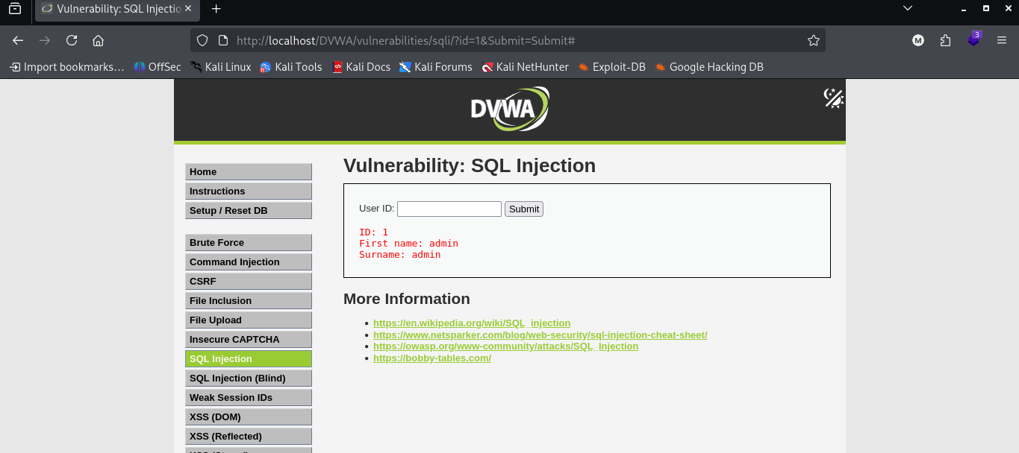

Note: ‘id=1’ is injectable parameter

Figure 27: Step 4 – Enter ‘1’ in the User ID section and click submit

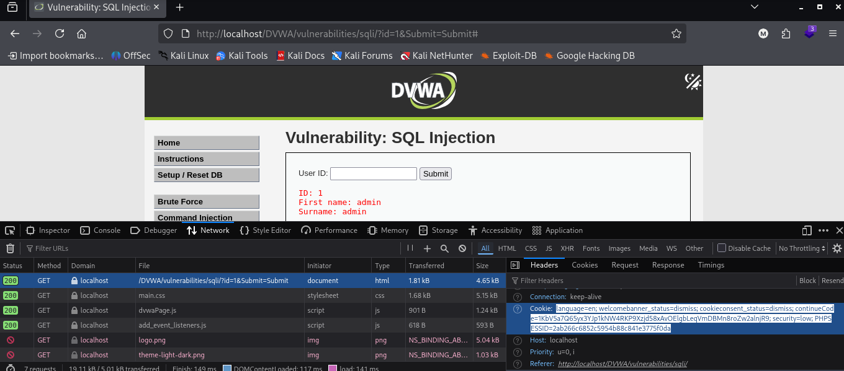

Figure 28: Step 5 – Record the cookie value to be used later on

Figure 29: Step 6 – Run Sqlmap in terminal to load all databases in DVWA

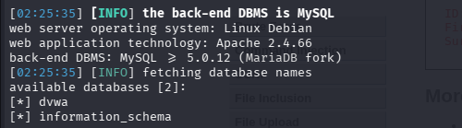

Figure 30: Step 7 – Databases found in DVWA

Figure 31: Step 8 – Enumerate Tables in the DVWA Database

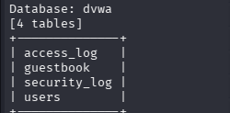

Figure 32: Step 9 – Tables Found

Figure 33: Step 10 – Dump ‘users’ Table

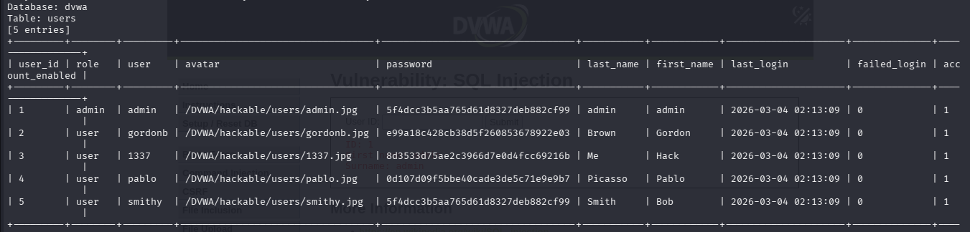

Figure 34: Step 11 – admin user Details found

Remediation Method
In this segment of the report, I will suggest an input sanitization method for the SQL Injection attack.

---------------------------------------------------------------------------------------------------------------------------
Step 1: Go to the below file. This is because in DVWA, it is a vulnerable file.
---------------------------------------------------------------------------------------------------------------------------

sudo nano /var/www/html/DVWA/vulnerabilities/sqli/source/low.php

It will show something like:

$id = $_GET['id'];

$query = "SELECT first_name, last_name FROM users WHERE user_id = '$id';";
$result = mysqli_query($GLOBALS["___mysqli_ston"], $query);

Problem with above:
- Directly inserting user input into SQL query
- No validation
- No prepared statements

---------------------------------------------------------------------------------------------------------------------------
Step 2: Replace vulnerable section with the below using Prepared Statements
---------------------------------------------------------------------------------------------------------------------------

<?php
if( isset( $_GET[ 'id' ] ) ) {

$id = $_GET['id'];

$stmt = $GLOBALS["___mysqli_ston"]->prepare(
"SELECT first_name, last_name FROM users WHERE user_id = ?"
);

$stmt->bind_param("i", $id); // "i" = integer
$stmt->execute();

$result = $stmt->get_result();

while( $row = $result->fetch_assoc() ) {
echo "<pre>ID: {$id}<br>First name: {$row['first_name']}<br>Surname: {$row['last_name']}</pre>";
}

$stmt->close();
}
?>

This will:
- Separate SQL logic from data
- Prevent injection payload execution
- Treat input strictly as data

Even if attacker sends 1' OR '1'='1, it will be treated as invalid integer input.

---------------------------------------------------------------------------------------------------------------------------
Step 3: Restart Apache
---------------------------------------------------------------------------------------------------------------------------

sudo systemctl restart apache2

---------------------------------------------------------------------------------------------------------------------------
Step 4: Run the Sqlmap Command Again
---------------------------------------------------------------------------------------------------------------------------

sqlmap -u "http://localhost/DVWA/vulnerabilities/sqli/?id=1&Submit=Submit#" --cookie="language=en; welcomebanner_status=dismiss; cookieconsent_status=dismiss; continueCode=1KbV5a7Q65yx3YJp1kNW4RKP9Xzjd58xAvOElgbLeqVmDBMn8roZw2alnjR9; security=low; PHPSESSID=2ab266c6852c5954b88c841e3775f0da" --dbs --batch

Expected Result:

[INFO] testing connection to the target URL
[WARNING] parameter 'id' does not seem to be injectable
[INFO] all tested parameters do not appear to be injectable

That means the vulnerability is fixed.

Reporting
The below is a short PTES report.

A penetration test was performed on a locally hosted instance of Damn Vulnerable Web Application (DVWA) running on Kali Linux to evaluate its vulnerability to SQL Injection attacks. In the reconnaissance and enumeration phases, it was found that the application endpoint `/vulnerabilities/sqli/` accepts user-supplied input through the `id` parameter. Testing was conducted in a controlled laboratory setting with permission. Using sqlmap, an automated exploitation was carried out, which confirmed that the `id` parameter was susceptible to SQL Injection at the “Low” security level. The tool successfully enumerated the available databases, identified the `dvwa` database, listed its tables, and extracted user credential hashes from the `users` table.

During the exploitation phase, database contents such as usernames and password hashes were extracted, showcasing inadequate input validation and the direct concatenation of user input into SQL queries. This vulnerability carried a high risk, with the potential to allow unauthorized data access, credential compromise, and additional lateral movement in actual deployments.

Remediation encompassed the use of prepared statements with parameterized queries in PHP, enforcing stringent input validation, and restarting the web service. A follow-up rescan using sqlmap verified that the injection point was no longer exploitable. The remediation successfully addressed the identified SQL Injection vulnerability and diminished the application’s attack surface as per PTES guidelines.

Non-Technical Summary
The below is a non-technical summary.

A security evaluation was conducted on a test web application, Damn Vulnerable Web Application (DVWA), located in a controlled lab setting. The examination revealed a vulnerability that enabled unauthorized access to sensitive information in the database due to improper management of user input. Utilizing the automated testing tool sqlmap, it was feasible to extract stored user account data, thereby demonstrating the potential business risk of data exposure and credential compromise. Secure coding practices that validate and handle user input correctly were implemented to resolve the issue. Subsequent tests verified that the vulnerability had been effectively addressed and that the application is now safeguarded against this method of attack.

Using Wappalyzer
In this segment of the report, I will show how I used Wappalyzer tool to identify tech stack of my Kali Linux machine.

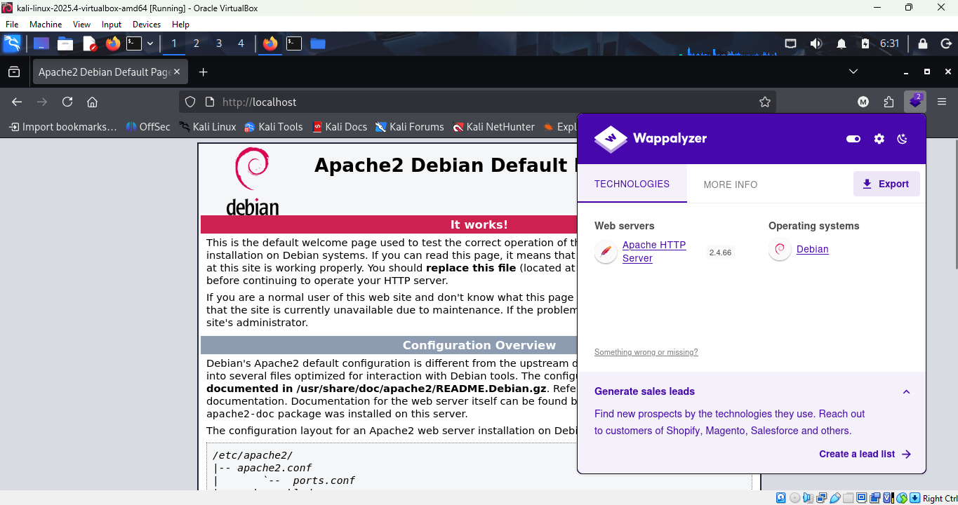

Figure 34: Local Host Page with Wappalyzer ON

As shown in the screenshot above, the tech stack that are found are:

- Web Servers (Apache HTTP Server)
- Operating Systems (Debian)

Lessons Learnt & Conclusion
Upon finishing this task, I learned how to effectively combine theoretical knowledge of Vulnerability Assessment and Penetration Testing (VAPT) with practical, hands-on application in a controlled lab environment. I gained a more profound understanding of vulnerability scanning with tools like Nmap and OpenVAS, risk prioritization via CVSS scoring, structured approaches such as PTES, and OSINT techniques using Maltego and Shodan. Using Metasploit and sqlmap, I acquired hands-on experience in leveraging real-world vulnerabilities in Metasploitable2, Windows 7, and DVWA. This experience helped me comprehend the significance of effective remediation through secure coding techniques like prepared statements and service hardening. This task enhanced my technical skills, analytical thinking, and reporting capabilities, while underscoring the vital importance of ethical authorization, documentation, and responsible disclosure in cybersecurity operations.

References
https://medium.com/@Aditya_2_1/hac-metasploitable-2-a-step-by-step-exploitation-guide-d87607e1d995

https://www.exploit-db.com/exploits/16317

https://huzzaifaasim.medium.com/exploiting-windows-smb-module-vulenerability-using-eternal-blue-exploit-metasploit-5fa3db5bab83

https://cheatsheetseries.owasp.org/cheatsheets/SQL_Injection_Prevention_Cheat_Sheet.html

